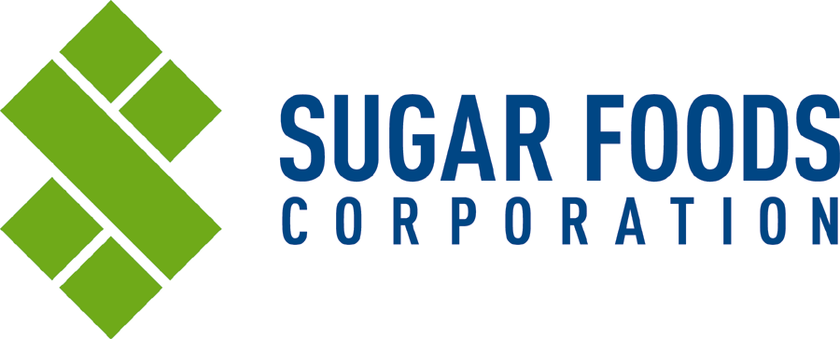
PRODUCT SPECIFICATION
1020 Crisp'N Fresh®
(50 / 1 oz Packets)
Revised: March 30, 2009

1. Product Type: Sulfite-Free Fruit and Vegetable Antioxidant

2. Container Information:
- Case Dimensions: 9.438”L x 6.438”W x 6.125”H
- Case Cube: 0.215 cu. ft.
- Gross Weight: 3.69 LB
- Pallet Pattern: 30 tie x 7 high = 210 cases/pallet

3. Sugar Foods Corporation Item Number: 1020; UPC: 0-00-86631-01020-5

4. Net Weights: 1 oz / packet; 3.13 LB / case

5. Ingredients: Sodium Erythorbate, Trisodium Citrate, Calcium Chloride Anhydrous.

6. Function:
Many fruits and vegetables can turn an undesirable brown color during processing and storage. This discoloration is the result of the enzymatic oxidation of naturally occurring compounds in the fruits and vegetables. The enzymatic oxidation is accelerated by exposure to air, heat, light, moisture, metals and other factors.

Crisp'N Fresh®, when mixed with water, blocks or inhibits the enzymatic oxidation which causes discoloration and flavor deterioration. The active ingredients react individually and collectively to create a stable PH environment, to bind with any metals which might accelerate the oxidation process, and to accept or scavenge the oxygen.

7. Physical, Analytical and Sensory Characteristics:
- Color/Appearance: Colorless
- Flavor/Aroma: Odorless and taste-free.

8. Recommended Storage and Handling Conditions: Cool, dry ambient conditions. Avoid excessive
heat and humidity.

9. Packaging and Labeling Requirements:
•Primary Packaging: Paper/Foil/Poly envelope
•Secondary Packaging: Corrugated shipping container
•A production code date is printed on the secondary packaging:
- Example: A3332457
  - Explanation: A = Shift (A-1st; B-2nd; C-3rd); 3 = Plant Location; 33 = Machine
Number; 245 = Julian Date; 7 = Year (2007)

10. Shelf Life: 12 months if stored in the recommended storage conditions.

11. Kosher Status: Not Kosher

